

**HRD TRANSPORT SERVICES**

Computer Science Project Work

Transport managemant

Ravi J. Makwana | Computer Science |

|  |  |  |
| --- | --- | --- |
| **Sr.No** | **Topic** | **Page No.** |
| **1** | **Preface** | **2** |
| **2** | **Acknowledgement** | **3** |
| **3** | **Hardware / Software Specification** | **4** |
| **4** | **Introduction** | **5** |
| **5** | **Source Code** | **6** |
| **6** | **Screenshots and working** | **17** |
| **7** | **Backend Database** | **23** |
| **8** | **Bibliography** | **25** |

Index

Preface

The ENIAC (Electronic Numerical Integrator and Computer) was the first electronic programmable computer built in the US. And since then, we have seen the way computers have evolved over time.

Computers are used for decreasing the human kind's load and carry out various operations. These are used widely for storing bulk data and carry out complex calculations.

The advancement of computers and Information Techn-

ology in the present time has raised the need for trained computer professionals and coders. Project designing in Computer Science is a part of CBSE curriculum in class XII. It helps to develop the thinking of student towards software technology and command control over programming languages. Such projects also play a key role in practical implementation of the theoretical concepts learned by the student.

Acknowledgment

Apart from the contribution and teamwork of the entire group, the success of any project depends largely on the encouragement and guidelines of many others.

We take this opportunity to express our deep gratitude to the people who have played a key role in the successful completion of this project.

Firstly we express our deep sense of gratitude to the luminary The Principal, Mrs. Anvita Kackar who had been continously motivating and supporting us.

We express our sincere thanks to The Vice Principal Mr. Manas Chatterjee for constant encouragement and guidance provided during the project.

Our sincere thanks to Mr. Suryakant Bebortha, Master-in-charge, a Guide, a mentor who critically reviewed our project at each of its stage and helped in solving each and every problem which we faced during the implementation of the project.

***HARDWARE SPECIFICATION***

|  |  |  |
| --- | --- | --- |
| ***SR. NO.*** | ***COMPONENTS*** | ***DESCRIPTION*** |
| 1 | System and Processor | Windows 10 Home  Intel Core i3 2.2GHz |
| 2 | Main Memory | 4 GB (RAM) |
| 3 | Hard Disk | 1000GB |

***SOFTWARE SPECIFICATION***

|  |  |  |
| --- | --- | --- |
| ***SR. NO.*** | ***SOFTWARE USED*** | ***DESCRIPTION*** |
| 1. | Python IDLE 3.7 64-bit | Used for Project Development and Frontend programming |
| 2. | MYSQL Server 5.5 | Used for Project Development and Storing data |
| 3. | Microsoft Office & Google Drive | Used for Documentation |

Introduction

Python is a widely used general-purpose, high level programming language. It was designed with an emphasis on code readability, and its syntax allows programmers to express their concepts in fewer lines of code. Python was designed to be highly extensible. This compact modularity has made it particularly popular as a means of adding programmable interfaces to existing applications.

MySQL is the world’s most popular open-source Relational Database Management System (RDBMS). SQL stands for Structured Query Language. The MySQL development project has made its source code available under the terms of General Public Licence, as well as under a variety of proprietary agreements. MySQL is an open-source database management system and many of the world's largest and fastest-growing organizations including Facebook, Google, Adobe, Alcatel Lucent and Zappos widely use it.

In this project, Python is used as Frontend & Backend and MySQL is used as Backend.

In this project, Python is used as Frontend & Backend and MySQL is used as Backend.

SOURCE CODE

**Module 1 (Main Body)**

import control

print()

print()

print("================================Welcome to HRD Travels==================================")

print()

print("***You Say it, We Book it !***")

print()

print()

def main():

print("1) Book Ticket"+'\n'

"2) View your Booking"+'\n'

"3) Cancel Ticket"+'\n'

"4) Exit")

print()

choice=int(input("Please Enter your choice (1-4): "))

print()

if choice==1:

control.book()

control.choices()

elif choice==2:

control.view()

control.choices()

elif choice==3:

control.cancel()

control.choices()

elif choice==4:

print()

print()

print(" ============================= THANK YOU ===============================")

quit()

else:

print()

print("Oops! Please Enter a valid Choice")

control.choices()

main()

**Module 2 (Main Body Use)**

import control

print()

print()

def main():

print("1) Book Ticket"+'\n'

"2) View your Booking"+'\n'

"3) Cancel Ticket"+'\n'

"4) Exit")

print()

choice=int(input("Please Enter your choice (1-4): "))

print()

if choice==1:

control.book()

control.choices()

elif choice==2:

control.view()

control.choices()

elif choice==3:

control.cancel()

control.choices()

elif choice==4:

print()

print()

print(" ============================= THANK YOU ===============================")

quit()

else:

print()

print("Oops! Please Enter a valid Choice")

control.choices()

**Module 3 (Choice Use)**

def choices():

import main_body_use

print()

choice_view=input("Enter 'y' to VIEW CHOICES and 'n' to EXIT: ")

if choice_view=="y":

print()

print()

main_body_use.main()

elif choice_view=="n":

print()

print()

print(" ============================= THANK YOU ===============================")

quit()

else:

import control

print()

print("Please Enter either 'y' Or 'n'")

print()

control.choices()

**MAIN PROGRAM**

def book():

import mysql.connector

mycon1=mysql.connector.connect(host="localhost",user="root",passwd="ravi",database="CSproject")

print("Please fill up the details given below to BOOK your Ticket-")

print()

main_name=input("Head Name: ")

main_name_lowered = main_name.lower()

cursor_search_name=mycon1.cursor()

cursor_search_name.execute("select lower(MainName) from price")

data_search_name=cursor_search_name.fetchall()

search_list=[]

for search_names in data_search_name :

search_list.append(search_names)

for ij in range (0,(len(search_list))):

if search_list[ij][0]==main_name_lowered :

print()

print(" Oops! Name already Taken ! ")

print(" Try some other Name ")

return

mobile=int(input("Mobile no.: "))

oomobile=str(mobile)

if len(oomobile) <10:

print(" Oops! Please Enter 10 digit mobile number")

print()

return

elif len(oomobile) >10:

print(" Oops! Please Enter 10 digit mobile number")

print()

return

print()

print("Select YOUR CITY from below: ") # for viewing my_city table #

print()

print("|Sr.no | City |")

print()

cursor2=mycon1.cursor()

cursor2.execute("select * from pick_up")

data2=cursor2.fetchall()

for my_city_name in data2:

print(my_city_name)

print()

mycity_number=int(input("Enter choice(1-5): "))

if mycity_number==1:

mycity="Udaipur"

elif mycity_number==2:

mycity="Delhi"

elif mycity_number==3:

mycity="Mumbai"

elif mycity_number==4:

mycity="Banglore"

elif mycity_number==5:

mycity="Chennai"

elif mycity_number >5:

print()

print(" Sorry..No other options Available")

print(" Return to View Choices or Quit")

print()

return

print()

print("Your Pick_Up city is ",mycity)

print()

print("Available Destinations from Your City are--")

print()

print("| FROM | TO | FARE PRICE |")

print()

cursor_menu=mycon1.cursor()

cursor_menu.execute("select * from menu where pick_ups='"+mycity+"'")

data_menu=cursor_menu.fetchall()

for menus in data_menu:

print(menus)

print()

print()

print("Select your DESTINATION from below : ") # for viewing destination table #

print()

print("|Sr.no | Destination|")

print()

cursor1=mycon1.cursor()

cursor1.execute("select * from destination")

data1=cursor1.fetchall()

for dest in data1:

print(dest)

print()

destination_number=int(input("Enter choice(1-5): "))

if destination_number==mycity_number:

print()

print(" Oops! Cannot keep SAME Destination and Pickup !")

print(" Return to View Choices or Quit")

return

elif destination_number==1:

destination="Udaipur"

elif destination_number==2:

destination="Delhi"

elif destination_number==3:

destination="Mumbai"

elif destination_number==4:

destination="Banglore"

elif destination_number==5:

destination="Chennai"

elif destination_number >5:

print()

print(" Sorry..No other options Available")

print(" Return to View Choices or Quit")

print()

return

print()

print("Your Destination is ",destination)

print()

print("Select Mode of Transport from below: ") # for viewing transport table #

print()

print()

print("|Sr.no| Transport| Price|")

print()

cursor3=mycon1.cursor()

cursor3.execute("select * from transport")

data3=cursor3.fetchall()

for trans in data3:

print(trans)

print()

mode_number=int(input("Enter choice(1-3): "))

if mode_number==1:

mode="Plane"

pprice=3000

elif mode_number==2:

mode="Bus"

pprice=1000

elif mode_number==3:

mode="Train"

pprice=500

elif mode_number >3:

print()

print(" Sorry..No other options Available")

print(" Return to View Choices or Quit")

print()

return

print()

print("Your Travelling mode is ",mode," with Per Person TRANSPORTATION Price of Rs",pprice)

print()

a=int(input("Enter number of members travelling: "))

print()

## Payment Process ##

print("Proceeding for Total Cost...")

tcost=0

if mycity_number==1 and destination_number==2:

tcost=899

elif mycity_number==1 and destination_number==3:

tcost=1500

elif mycity_number==1 and destination_number==4:

tcost=3500

elif mycity_number==1 and destination_number==5:

tcost=4000

elif mycity_number==2 and destination_number==1:

tcost=901

elif mycity_number==2 and destination_number==3:

tcost=3500

elif mycity_number==2 and destination_number==4:

tcost=4999

elif mycity_number==2 and destination_number==5:

tcost=4999

elif mycity_number==3 and destination_number==1:

tcost=1100

elif mycity_number==3 and destination_number==2:

tcost=2500

elif mycity_number==3 and destination_number==4:

tcost=1238

elif mycity_number==3 and destination_number==5:

tcost=4000

elif mycity_number==4 and destination_number==1:

tcost=3500

elif mycity_number==4 and destination_number==2:

tcost=4999

elif mycity_number==4 and destination_number==3:

tcost=1238

elif mycity_number==4 and destination_number==5:

tcost=2000

elif mycity_number==5 and destination_number==1:

tcost=4000

elif mycity_number==5 and destination_number==2:

tcost=4999

elif mycity_number==5 and destination_number==3:

tcost=4000

elif mycity_number==5 and destination_number==4:

tcost=2500

per_person_total_price = (tcost+pprice)

final_price= per_person_total_price*a

cursor_costing=mycon1.cursor()

print()

print()

print("Your per person Fare Price is:",tcost)

print("Your per person Transportation Price is:",pprice)

print("& Number of people Travelling are:",a)

print()

print("So Your Final Cost is: Rs(",tcost,"+",pprice,") *",a,"= Rs",final_price)

print()

print()

confirmation=input(" CONFIRM ? (press 'y' for Proceeding and Any Other Key for Cancelling): ")

if confirmation=="y":

values_costing="insert into price(MainName,No_of_Members,Per_Person_Price,Total_cost) values('{}',{},{},{})".format(main_name,a,per_person_total_price,final_price)

cursor_costing.execute(values_costing)

mycon1.commit()

print()

else:

print()

print(" BOOKING CANCELLED ")

print()

print("========================================================================================")

return

print("Enter Names and Age of all ",a," members" )

cursor4=mycon1.cursor()

print()

for i in range (1,a+1):

print(i,")",end=" ")

m_name=input("Person name: ")

print(i,")",end=" ")

m_age=int(input("Age: "))

values4="insert into booking(MainName,MemberName,Age,PickUp,Destination,Transport,TicketPrice) values('{}','{}',{},'{}','{}','{}',{})".format(main_name,m_name,m_age,mycity,destination,mode,per_person_total_price)

cursor4.execute(values4)

mycon1.commit()

print()

print()

print(" BOOKING SUCCESSFUL !")

print()

print("[ Further Details regarding Payment Method will be shared to you on Mobile Number",mobile," ]")

print()

print(" Thank You for Booking !!")

print()

print("========================================================================================")

mycon1.close()

#########################################################################

def view():

import mysql.connector

mycon2=mysql.connector.connect(host="localhost",user="root",passwd="ravi",database="CSproject")

cursor5=mycon2.cursor()

cursor6=mycon2.cursor()

cursor_bill=mycon2.cursor()

print()

print("For Viewing Your Booked Ticket-")

print()

ask_name=input("Enter Name of the person by whose name the Ticket has been Booked: ")

cursor5.execute("select * from booking where mainname='"+ask_name+"'")

data5=cursor5.fetchall()

cursor6.execute("select count(mainname) from booking where mainname='"+ask_name+"'")

data6=cursor6.fetchall()

counting_list1=[]

for counting1 in data6:

counting_list1.append(counting1)

exact_count1=counting_list1[0][0]

print()

print()

print("================================YOUR BOOKING==========================================")

print()

if exact_count1 ==0:

print(" Oops! No Ticket has been booked by such name ")

print()

print("========================================================================================")

return

elif exact_count1 !=0:

print()

print(" Member List--")

print()

print("|MainName|MemberName|Age|Pickup|Destination|Transport|PerPersonPrice|")

print()

for traveller_info in data5:

print(traveller_info)

print(" ========================================== ")

print()

print()

print(" Your Bill-- ")

print()

cursor_bill.execute("select * from price where MainName='"+ask_name+"'")

data_bill=cursor_bill.fetchall()

print("|MainName|No.of Members|PerPersonPrice|TotalCost|")

print()

for bill_view in data_bill:

print(bill_view)

print()

print("========================================================================================")

print()

mycon2.close()

#########################################################################

def cancel():

print("================================Cancelation Process========================================")

print()

import mysql.connector

mycon3=mysql.connector.connect(host="localhost",user="root",passwd="ravi",database="CSproject")

cursor7=mycon3.cursor()

cursor8=mycon3.cursor()

cursor9=mycon3.cursor()

cursor_bill_cost=mycon3.cursor()

cursor_bill_update1=mycon3.cursor()

cursor_bill_update2=mycon3.cursor()

cursor_delete=mycon3.cursor()

the_name=input("Enter Name of the person by whose name the Ticket Was Booked: ")

cursor8.execute("select count(mainname) from booking where mainname='"+the_name+"'")

data8=cursor8.fetchall()

counting_list2=[]

for counting2 in data8:

counting_list2.append(counting2)

exact_count2=counting_list2[0][0]

if exact_count2 ==0:

print()

print(" Oops! No Ticket has been booked by such name !")

print()

return

elif exact_count2 !=0:

print()

sub_name=input("Enter the name of the Member whose ticket is to be Cancelled: ")

cursor9.execute("select count(membername) from booking where membername='"+sub_name+"'")

data9=cursor9.fetchall()

counting_list3=[]

for counting3 in data9:

counting_list3.append(counting3)

exact_count3=counting_list3[0][0]

if exact_count3 ==0:

print()

print(" Oops! No Ticket has been booked by such name !")

print()

return

elif exact_count3 !=0:

listss=[]

cursor7.execute("delete from booking where mainname='"+the_name+"' and membername='"+sub_name+"'")

mycon3.commit()

cursor_bill_cost.execute("select No_of_Members,Per_Person_Price,Total_Cost from price where MainName='"+the_name+"'")

data_cost_bill=cursor_bill_cost.fetchall()

for bill_details in data_cost_bill:

listss.append(bill_details)

aa=listss[0][0]

bb=listss[0][1]

cc=listss[0][2]

aaa=aa-1

bbb=bb

ccc=(cc-bb)

if aaa==0:

cursor_delete.execute("delete from price where Mainname='"+the_name+"'")

mycon3.commit()

else:

cursor_bill_update1.execute("update price set No_of_Members={} where MainName='{}'".format(aaa,the_name))

mycon3.commit()

cursor_bill_update2.execute("update price set Total_Cost={} where MainName='{}'".format(ccc,the_name))

mycon3.commit()

print()

print()

print(" Ticket Cancelled Successfully!")

print()

print(" Your Money will be Refunded within 24 hrs.")

print()

print("========================================================================================")

print()

mycon3.close()

#########################################################################

def choices():

import main_body_use

print()

choice_view=input("Press 'y' to VIEW CHOICES and 'n' to EXIT: ")

if choice_view=="y":

print()

print()

main_body_use.main()

elif choice_view=="n":

print()

print()

print(" ============================= THANK YOU ===============================")

quit()

else:

import choicee_use

print()

print("Please Enter either 'y' Or 'n'")

print()

choicee_use.choices()

#########################################################################

Screenshots and Working

After each input in python, the changes in MySql database has been displayed consequently

First all the required tables are empty:-

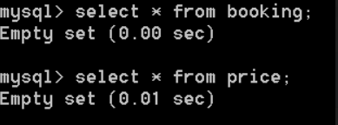

The given below execution shows the process of booking throuh HRD Travels

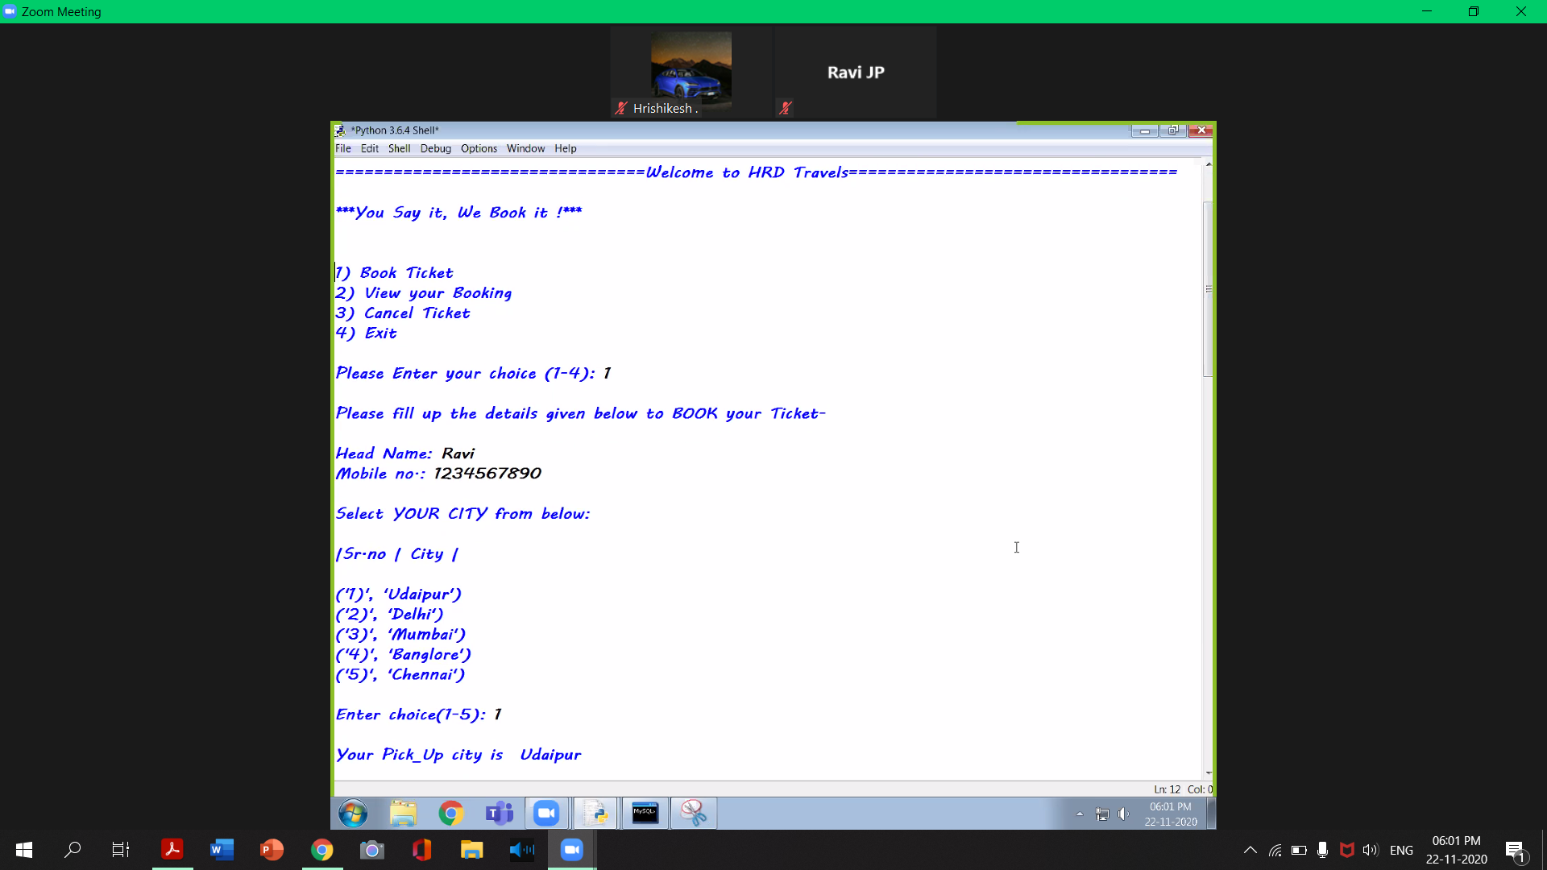

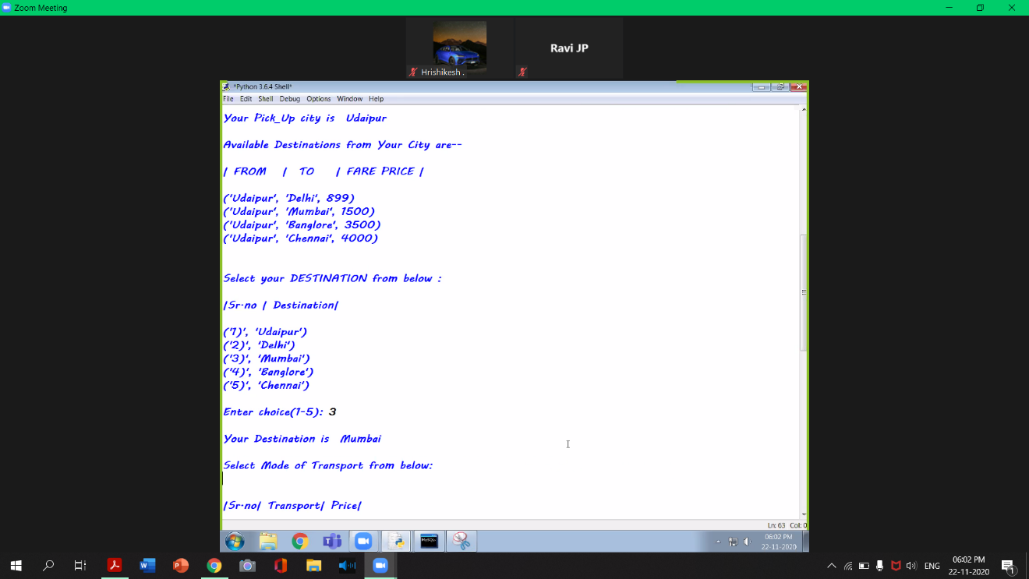

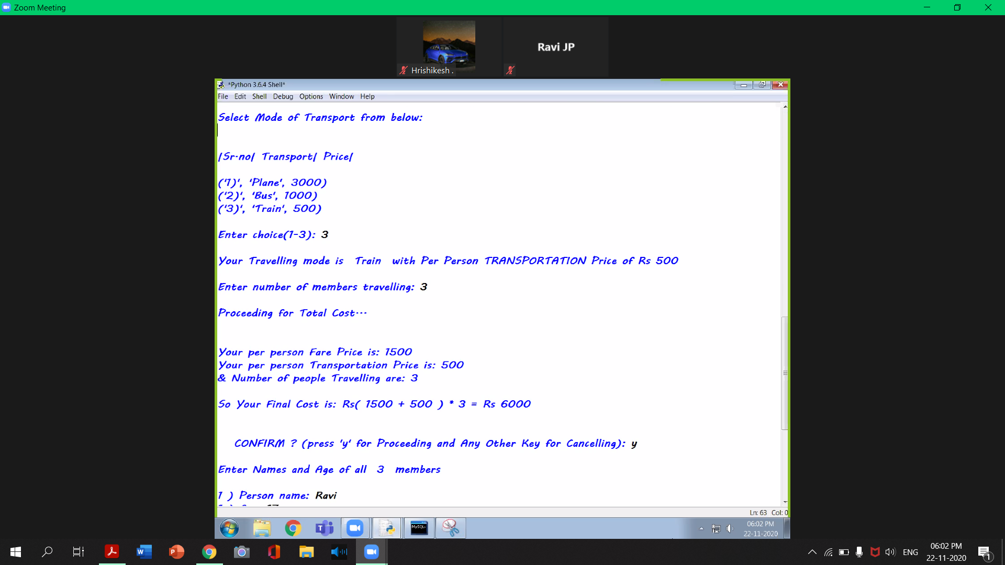

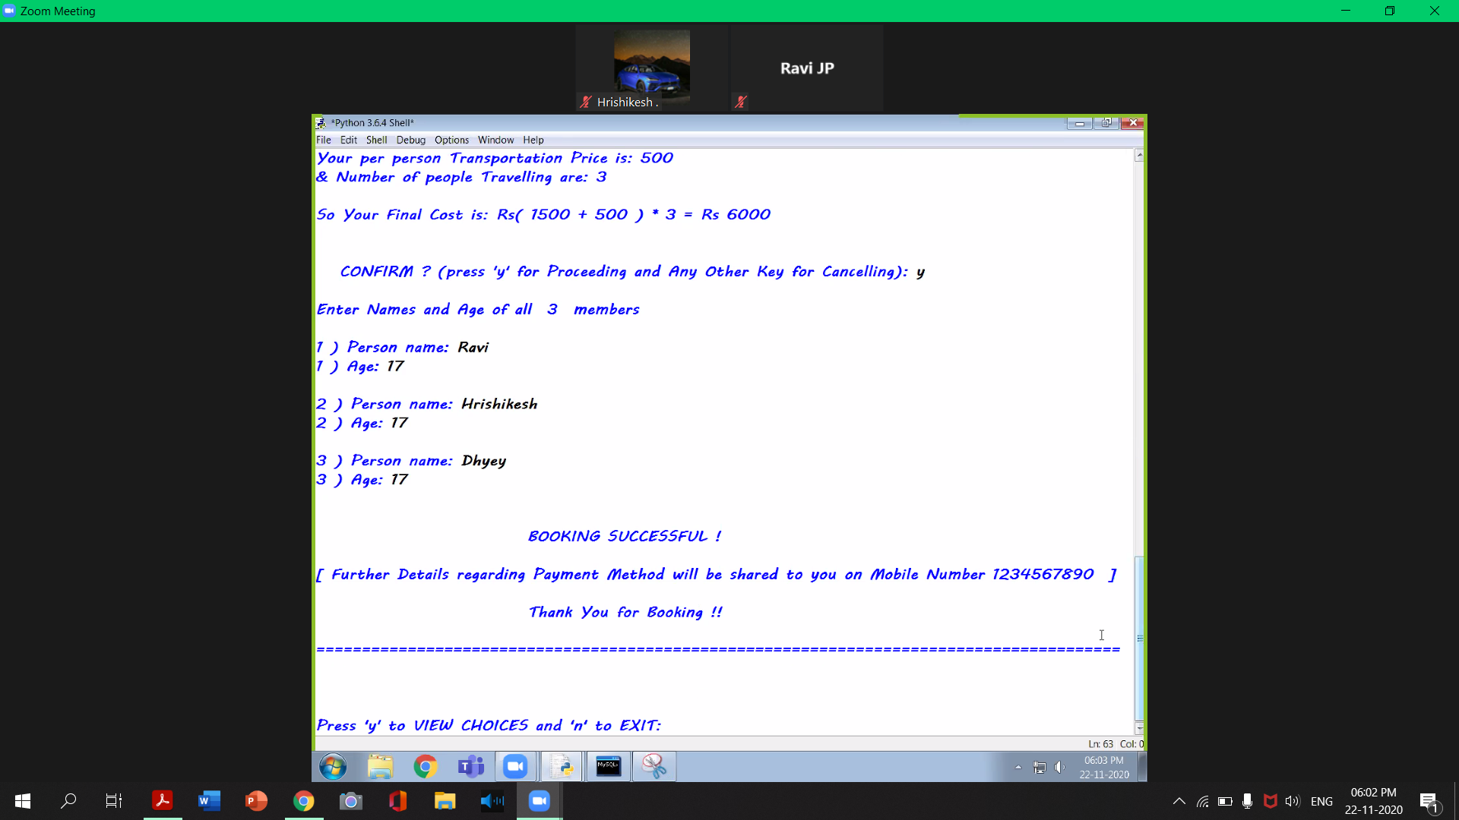

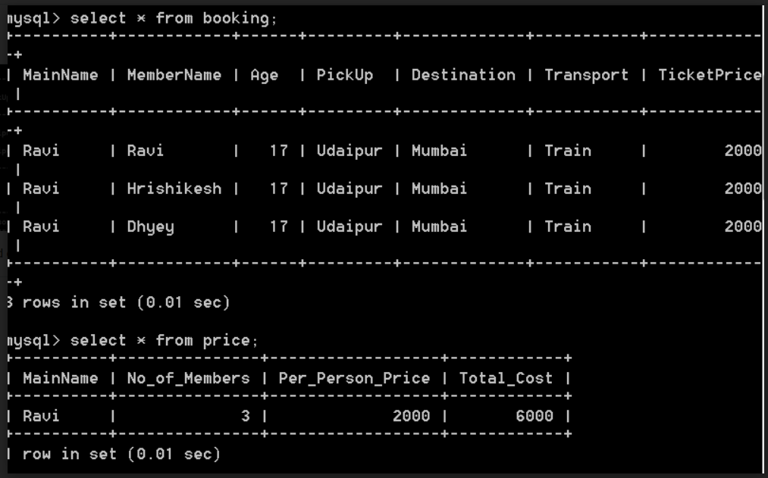

*This displays total fare price*

The given below execution of code shows viewing of tickets by customer

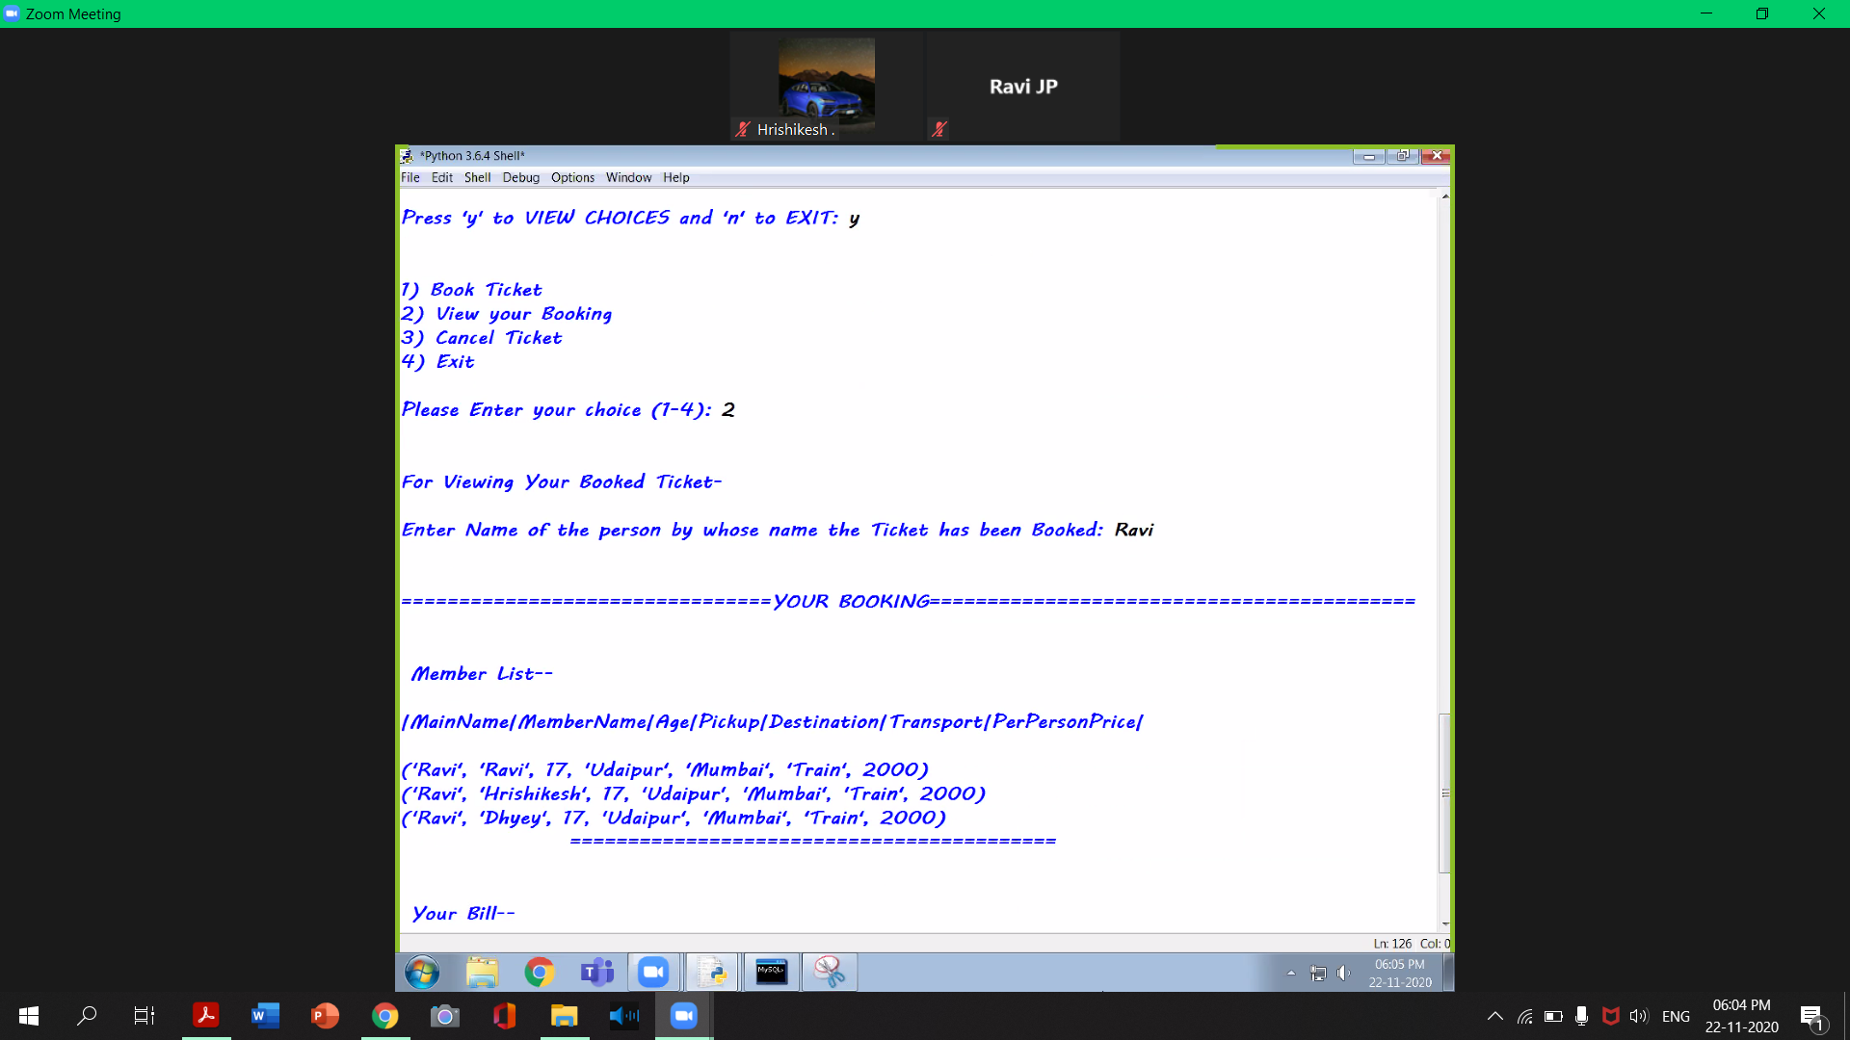

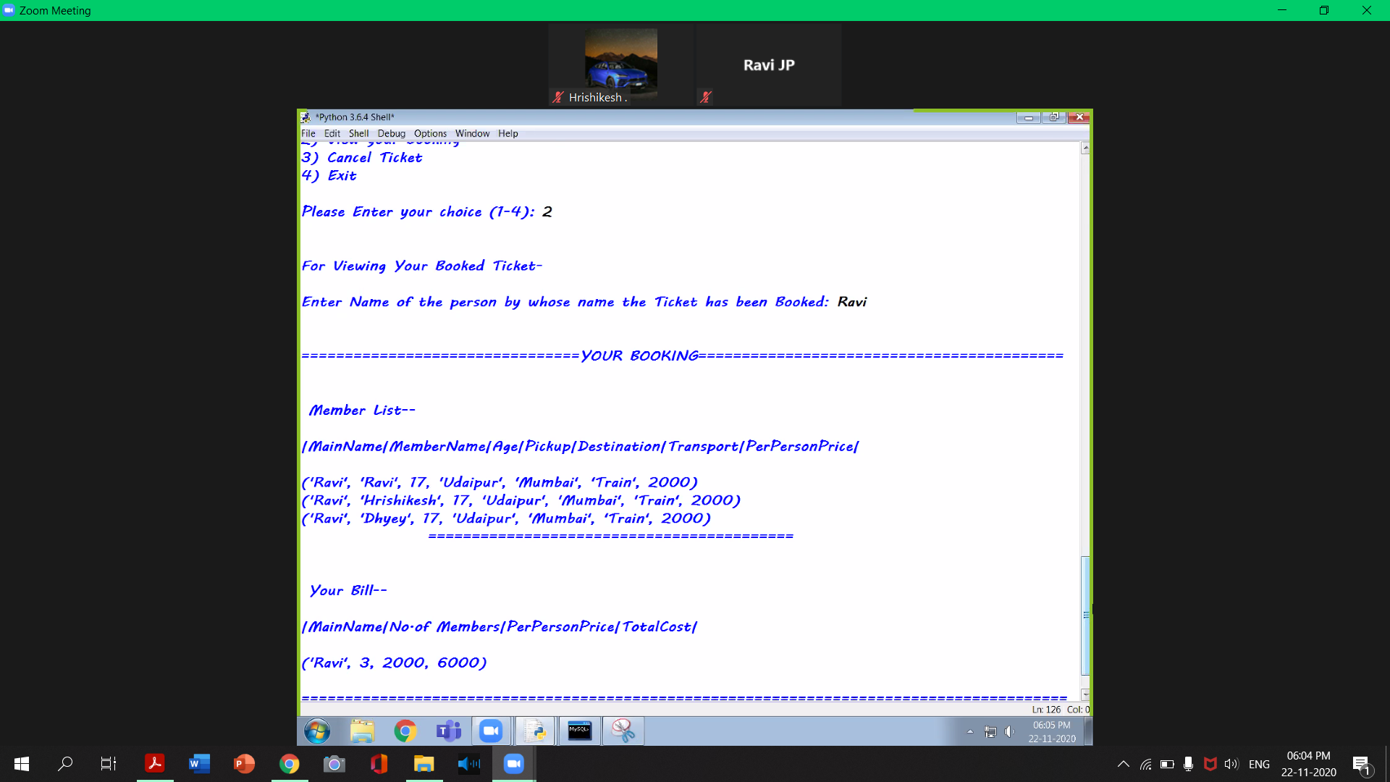

The given below execution of code shows cancelling of tickets

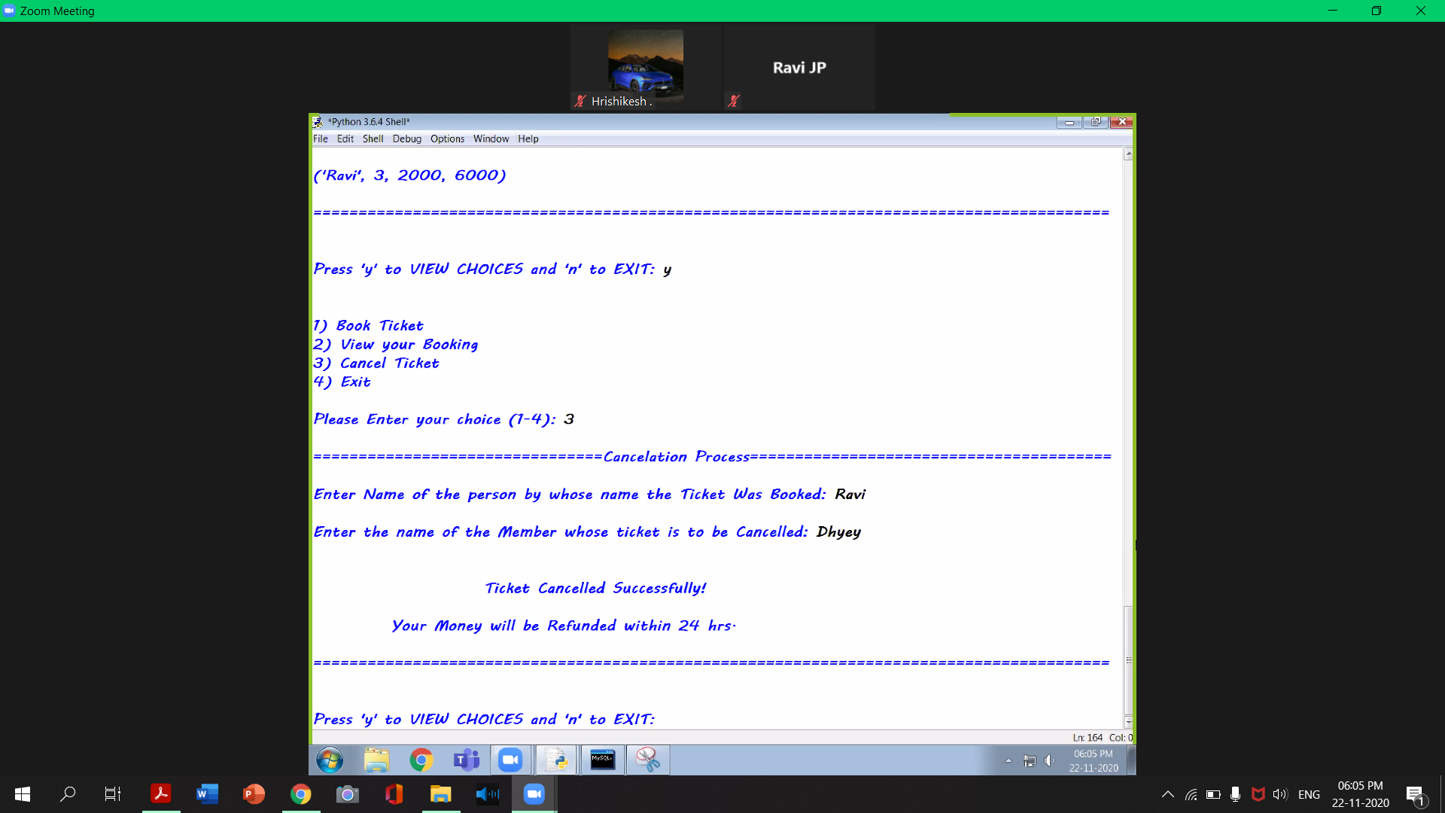

Updated Sql Database with price

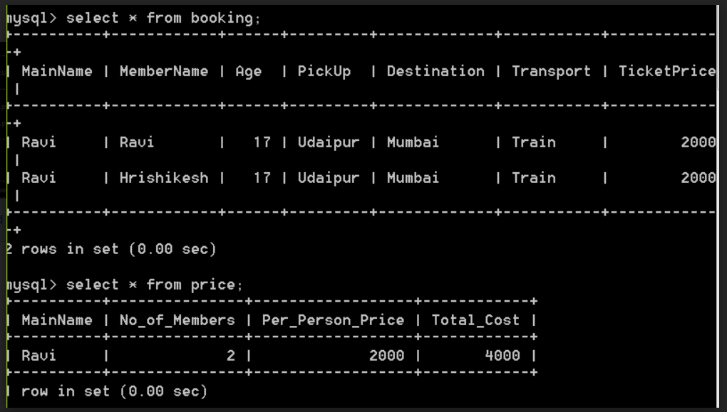

This screen shot shows updated bill on customers’ side

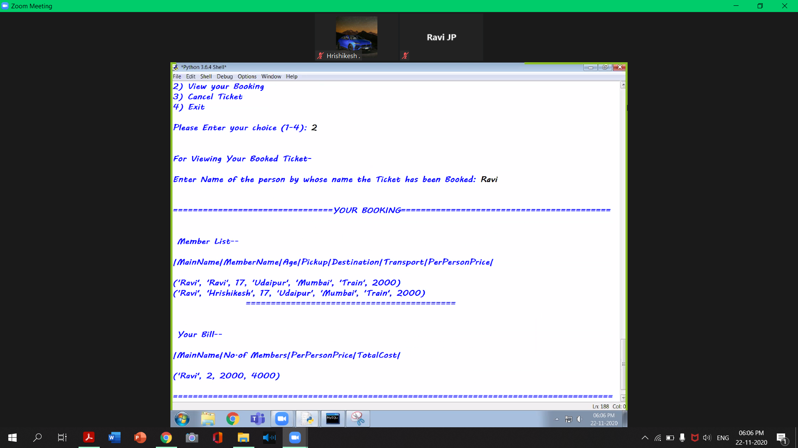

End Of Program Execution

Backend Database

List of pickup drop permutations: -

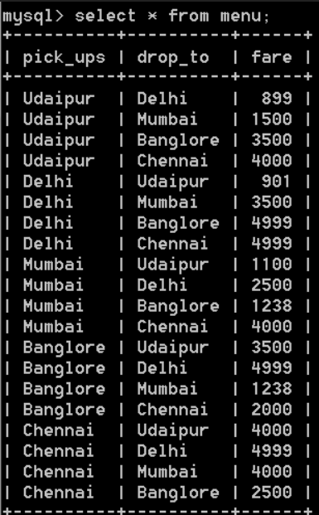

Price Table described

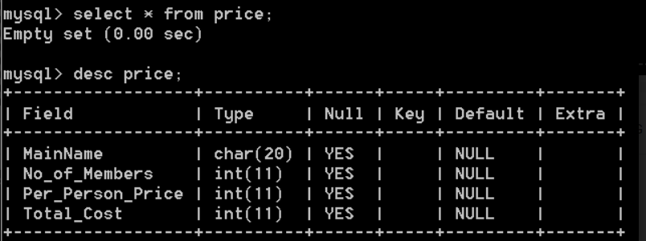

Booking table described:-

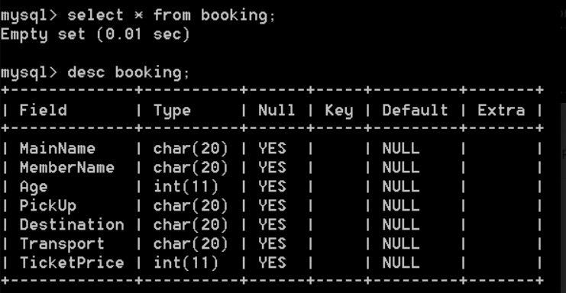

Transport table: -

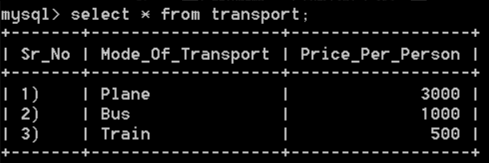

Pickup and destination tables: -

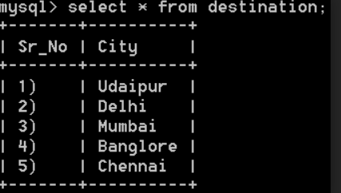

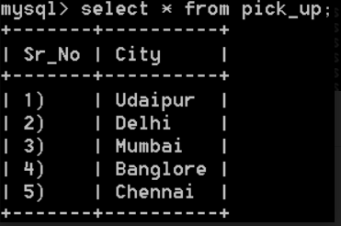

Bibliography

Web References

1) [https://www.ZetCode.com](https://www.zetcode.com/)

2) [https://www.digitalocean.com](https://www.digitalocean.com/)

Textbook References

1) Computer Science with python-A Textbook for class XII

-NCERT publication

2) Computer Science with python

-Sumita Arora

Other than the above mentioned books and sites, the suggestions and supervision of our teacher and our class experience also helped us to develop this software project.